Instruction Manual for Mini Vortex Mixer VM-100

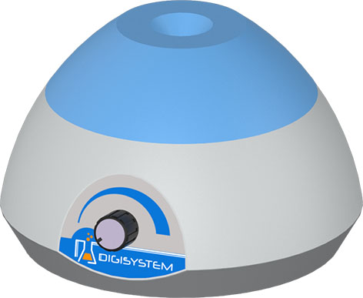
(1)
- Mixing head
- Speed control knob

(2)

- Place the mini. vortex mixer on a flat and stable bench top. Place the vortex mixer securely away from the edge of bench to avoid the vortex mixing falling off the bench top. Plug the vortex mixer into a properly grounded outlet.
- Take the tube to be mixed and pressed downward against the head to activate the mixing action. Rotate the speed control knob to set the desired mixing speed. When finished mixing, lift the tube upward
Troubleshooting
Caution: Always disconnect the power cord before troubleshooting.
Trouble | Cause | Remedy
Instrument inoperative | Power cord not connected to outlet. | Plug instrument in.
Instrument inoperative | Dead power output. | Change to different output.
Instrument inoperative | Defective electronic component. | Contact your distributor for repair.
Motor doesn’t rotate | Motor is broken. | Contact your distributor for repair.
Motor doesn’t rotate | PC board is broken. | Contact your distributor for repair.
Speed can’t not be controlled | Variable resistance is broken | Contact your distributor for repair.
Speed can’t not be controlled | PC board is broken. | Contact your distributor for repair.

Circuit Diagram
